|  |  |  |  |
| --- | --- | --- | --- |
| Description: Description: S:\AdminShared\All Staff\1 College Logo's\Baldivis_Logo_colour.jpgName: | \_\_\_\_\_\_\_\_\_\_\_\_\_\_\_\_\_\_\_\_\_\_\_\_\_\_\_\_\_\_\_\_\_\_\_\_\_\_\_\_\_\_\_\_\_\_\_\_\_\_\_ | | Date: *\_\_\_\_\_\_\_\_\_\_\_* |
|  | **Year 11 Applications**  **Test 6, 2020**  **Topics – Simultaneous Equations and Piece-wise functions** | | 45  = % |
| **Total Time:** | ***47*** *minutes* |  | |
| **Total Reading:** | ***2*** *minutes* |
| **Total Working:** | *45 minutes* |
| **Weighting:** | *8% of the year.* |
| **Equipment:** | *SCSA Formula Sheet; 1 page notes (A4 one side,* ***Unfolded****), CASIO ClassPad; Scientific Calculator* | | |

**Resource Free Section – 18 min 1 min reading time [18 marks]**

1. **[8 marks: 4, 4]**

Use algebraic techniques to solve the following simultaneous equations.

a) $2x+3y=0$

$$x-7y=34$$

b) $k=5j+10$

$$3j=20-k$$

1. **[7 marks: 2, 2, 2, 1]**

Draw and label graphs of the following on the axes below:

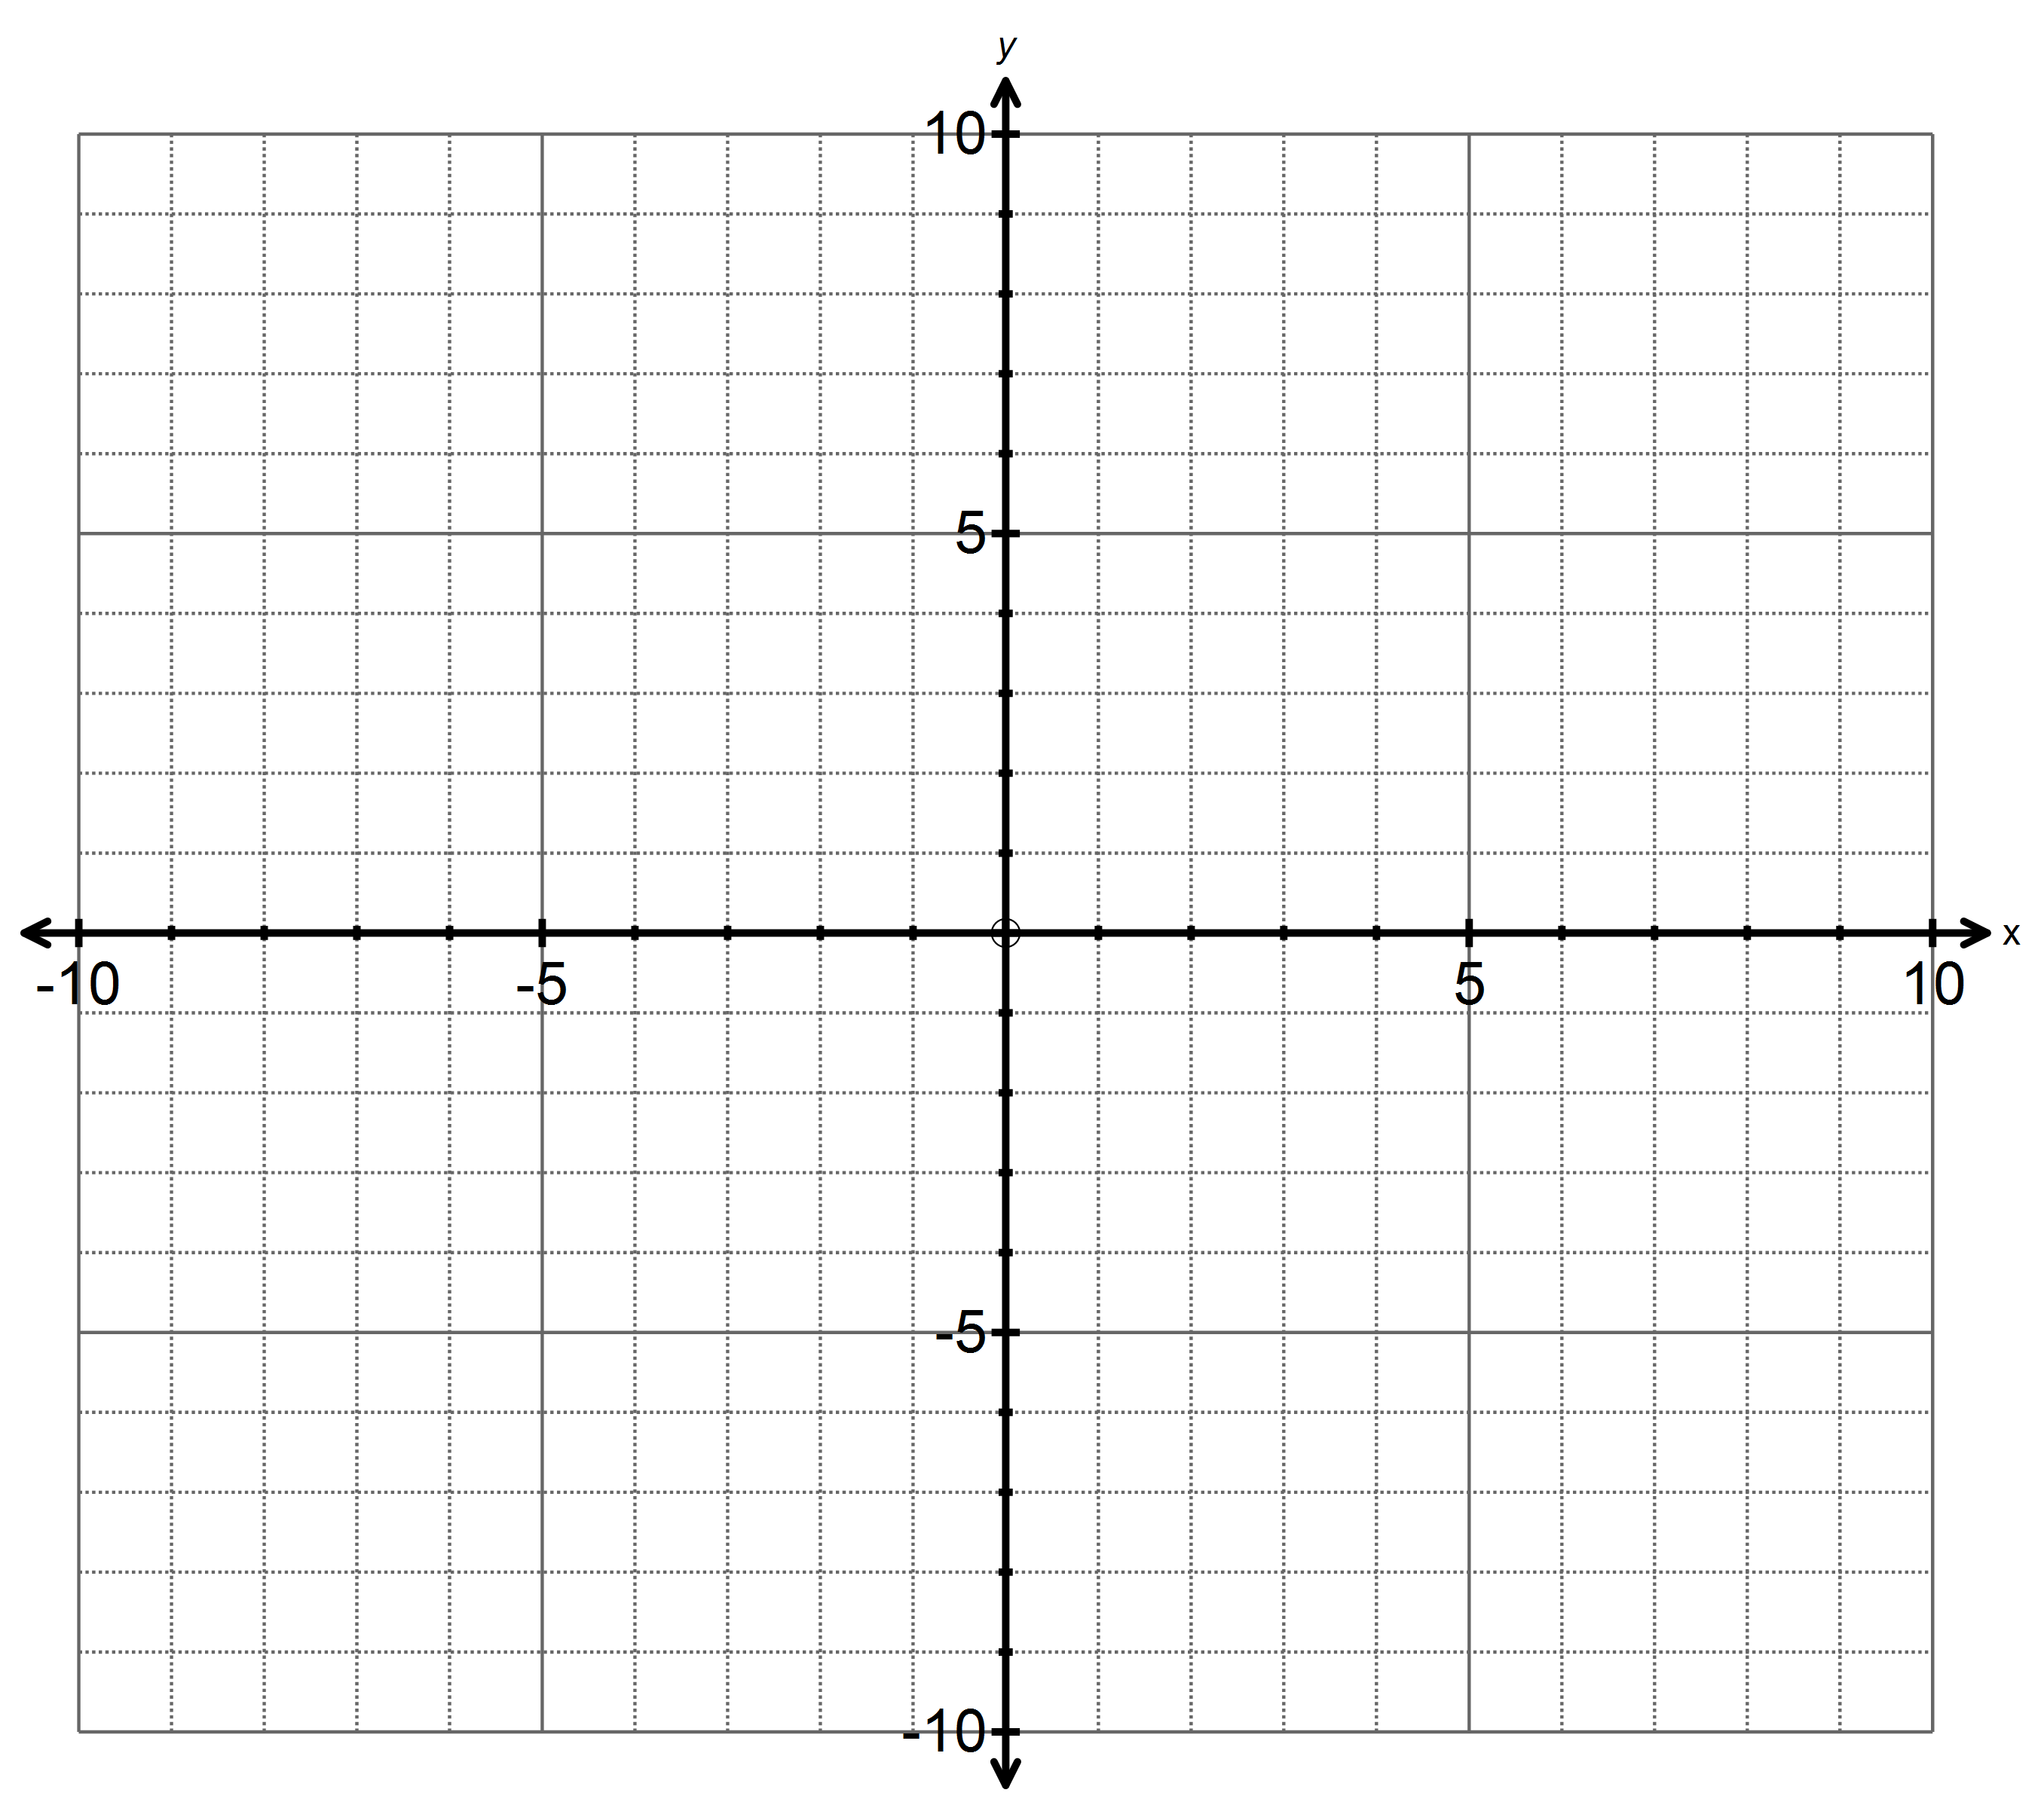

$y=2x+1$

$2y=4x-6$

$x+y=5$

$y=-3$

1. **[3 marks]**

Solve the following simultaneous equations $y=5-x$ and $3x-y=3$

-End of Resource Free Section-

**Resource Rich Section – 27 min 1 min reading time [27 marks]**

1. **[9 marks: 2, 2, 2, 2, 1]**

Mr Morgan’s phone plan has a monthly fixed fee of $15 and he is then charged 25c per phone call.

a) What will she be charged in a month in which he makes 10 phone calls? How much for 30 phone calls?

b) Write a rule (equation) giving the money (M) that Mr Morgan will be charged for making *p*  phone calls.

c) The graph below shows the charges for phone calls only (no texting) by Mrs Smith’s phone company. Using your answer to (b), plot a line representing the cost of Mr Morgan’s plan on the same graph.

d) Use the graph above to decide what Mrs Smith’s plan charges as a monthly fee and what she is charged per phone call.

e) From the graph, for what range numbers of phone calls will Mrs Smith’s plan cost more than Mr Morgan’s?

1. **[3 marks ]**

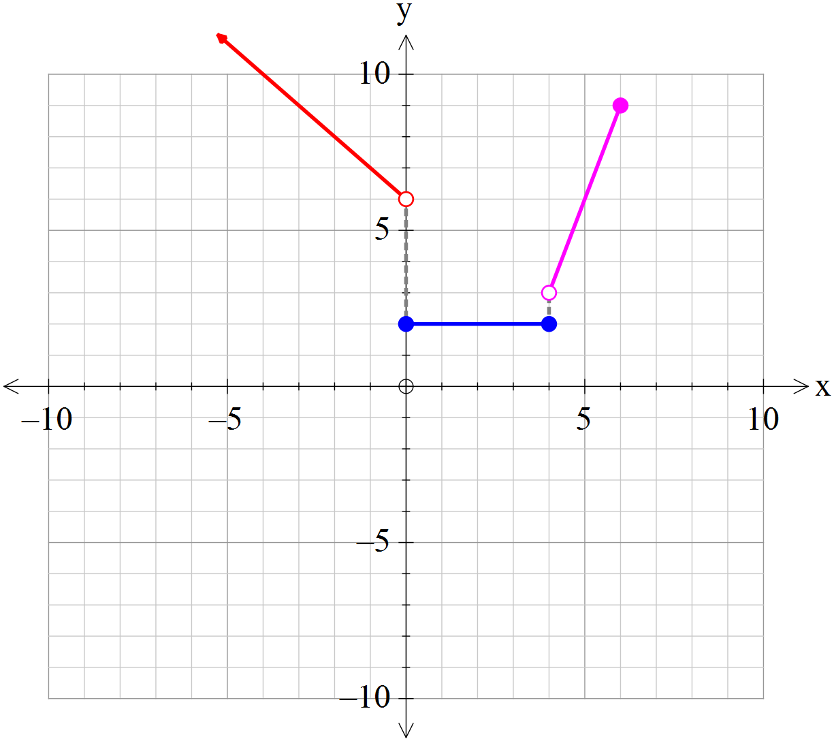Write down the rules for the piece wise defined function drawn below;

1. **[6 marks: 2, 2]**

Ben and Holly each buy tickets for themselves and their families for the elf concert. Ben buys two child’s tickets and four adult tickets and he pays $24. Holly buys three children’s tickets and three adult tickets and she spends $21.

a) Write two equations in terms of, *c,* the price of a child’s ticket and, *a*, the price of an adult ticket, for what each Ben and Holly spent.

b) Solve your equations to determine the cost of each type of ticket.

|  |  |
| --- | --- |
|  |  |
|  |  |

1. **[2 marks ]**

Find the equation of the line that passes through the points below

1. (-1, 4) and (0, 5) b) (-2,-1) and (0, 3)
2. **[7 marks: 4, 2, 1 ]**

Alisa has an ant farm and she notes that the population of ants can be modeled by the linear equation $A=50+5d$ with $d$ being the number of days since she got the ant farm.

Alisa’s brother had an ant farm of his own long before Alisa got hers so he already had 350 ants when Alisa got her farm.

Alisa’s brother’s ant farm contracts a disease on the day which Alisa got her ant farm. Alisa’s brother’s ants no longer reproduce but instead 15 ants are dying a day.

a) Draw two equations on the graph below for the number of ants which Alisa and her brother have.

b) How many ants do they each have after 10 days?

c) Hence determine after how many days Alisa and her brother have the same number of ants.